**Instituto Politécnico Nacional**

**Escuela Superior de Cómputo**

*Fundamental Analysis of Circuits*

Practice 5: Mesh Analysis.

Group: 1CV13

Team: 7

Members:

Pastor Martínez Luis Enrique

Partido Terrón Luis Alberto

Pérez Garduño José Emiliano

Professor:

Raúl Santillán Luna

Practice day: October 16, 2017

Delivery day: October 23, 2017

**Index:**

1. Objective
2. Introduction
3. Development
4. Calculations
5. Conclusions

**Objective:**

* Apply the mesh analysis method for mesh to the resolution of a circuit with direct current and alternative current.

**Introduction:**

Mesh: A mesh (also called a loop) is simply a path through a circuit that starts and ends at the same place. Mesh analysis technique, uses mesh currents as variables, instead of currents in the elements to analyze the circuit. Therefore, this method absolutely reduces the number of equations to be solved. Mesh analysis applies the Kirchhoff’s Voltage Law (KVL) to determine the unknown currents in a given circuit. Mesh analysis is also called as mesh-current method or loop analysis. After finding the mesh currents using KVL, voltages anywhere in a given circuit can be determined by using Ohms law.

Steps to Analyze the mesh analysis technique

1. Check whether there is a possibility to transform all current sources in the given circuit to voltage sources.
2. Assign the current directions to each mesh in a given circuit and follow the same direction for each mesh.
3. Apply KVL to each mesh and simplify the KVL equations.
4. Solve the simultaneous equations of various meshes to get the mesh currents and these equations are exactly equal to the number of meshes present in the network.

**Development:**

Testing of the mesh analysis in direct current.

1. Determine in analytic form, the correct direction and the values of the following mesh and voltage of every element to write them down in table 1.
2. Using some software for simulation obtain the same values requested in the last part and write the results in table 1.

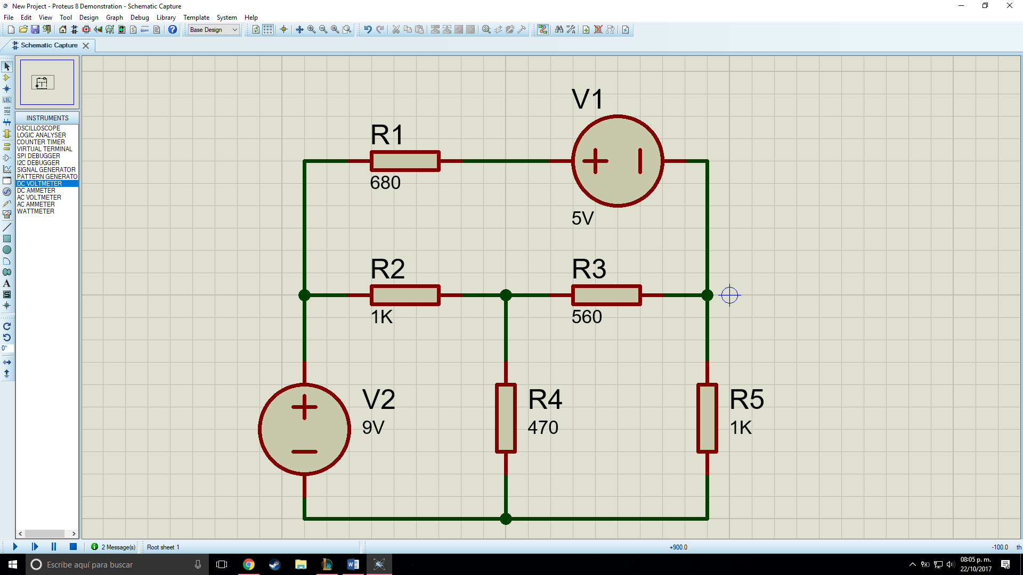

|  |  |  |  |
| --- | --- | --- | --- |
| Measurements | Theoretical value. | Value measured. | Simulated value. |
| I1 | 11.94mA | 17.94mA | -2.15mA |
| I2 | -11.97mA | -11.97mA | 8.40mA |
| I3 | .16mA | 0.16mA | -5.86mA |
| VR1 | -2.1V | -2.1V | 1.46V |
| VR2 | 7V | 7.04V | -6.25V |
| VR3 | -1.72V | -1.74V | 0.22V |
| VR4 | 9mV | 78mv | 2.75V |
| VR5 | -1.65V | -1.66V | 2.54V |

|  |  |
| --- | --- |
| Intensity of the circuit measured in milliamperes.  (mA) |  |
| Voltage of each element measured in volts. (V) |  |

**Questioner:**

1. What Is a mesh in circuit analysis?

It´s a tie that doesn’t have any other tie within it.

1. Describe in what the mesh analysis method in circuits theory.

It consists in creating an equation system to resolve the circuit that can´t be simplified by reduction.

1. What advantages do we get applying mesh analysis?

Facilitates the analysis creating a small number of equations to resolve.

1. The values calculated of voltage and current of each resistor coincide with the ones measured, why?

Because they aren´t ideal elements so they have a margin of error.

**Conclusions:**

Luis Enrique:

Luis Alberto:

José Emiliano: We could only do the direct current part due to the fact that we couldn´t find a 0.5 Henry´s inductor anywhere, however the other part was completed and fast due to it being easy, we studied the mesh and got all of its components with ease.

***Bibliography:***

<http://www.circuitstoday.com/function-generators>

<http://www.facstaff.bucknell.edu/mastascu/elessonshtml/basic/basic5kv.html>

<http://ffden-2.phys.uaf.edu/211.fall2000.web.projects/Jeremie%20Smith/page3.htm>

<http://www.bkprecision.com/support/downloads/function-and-arbitrary-waveform-generator-guidebook.html>

<https://learn.sparkfun.com/tutorials/how-to-use-an-oscilloscope>

<http://www.electronics-tutorials.ws/dccircuits/dcp_6.html>

<http://www.ee.ic.ac.uk/hp/staff/dmb/courses/ccts1/00300_Nodal.pdf>